Development documentation

17.5.23

I added the navigation bar on the top of the header tag by following from this website <https://www.w3schools.com/css/tryit.asp?filename=trycss_navbar_basic_css>.

19.5.23

Because my navigation bar still has dot point. I got help from Rob to reset my css using this link which contains the code.

<https://meyerweb.com/eric/tools/css/reset/>

Additionally, I linked one stylesheet to reset.css to remove dot points from my navigation bar then added style.css and scss/main.scss stylesheets because linking to css to main.scss through @import does not work.

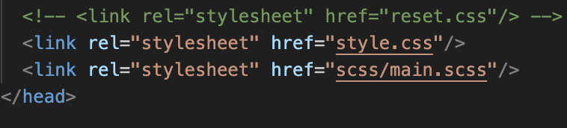

I changed the layout from grid to flex because it’s responsive to both mobile and desktop devices.

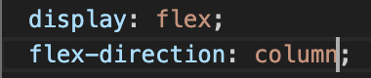

Hence, I added my images using the img tag with figcaptions as part of figure tag in html. And added align-self to figcaption in css to position below the image.

20.5.23

I created a form consists of User First Name, User Last Name, User Id, Movie Genre, Phone Number, Email, Movie Name, Rating and Movie image. Using the template from coding challenge.

I found information about how to create a rating systems for users to input data to the form. By classifying input type as radio and adding stars using span class.

And to add image when the user searches for their image from a folder.

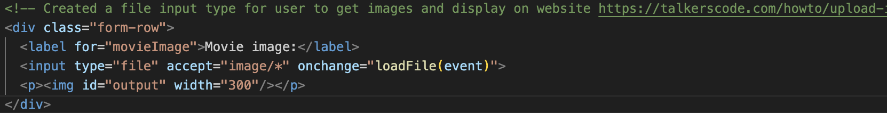

21.5.23

I placed my form on the left and tasks at the right side of the website. By using margin-top: -16em for form tag and Tasks: margin-left: 60em for Tasks tag.

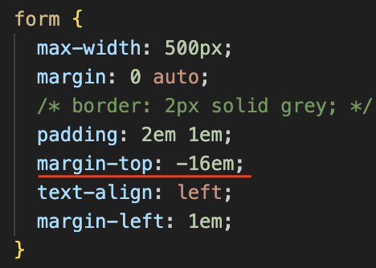

Furthermore, I created a task list that enables the user to select a task and display it individually. Watched a video on youtube about showing/hiding div based on dropdown selection using HTML, CSS and JQuery. And converting to plan javascript using codentools.com.

<https://www.youtube.com/watch?v=f3fALMAVBOE>

Additionally, I moved the labels of my form to the top and user input to the bottom and adjusted my submit button.

For navigation bar I used my web app design assignment to create a menu that’s positioned on the left side and title at the center.



And I resetted my css by placing on the top of the styles.css file.

<https://www.digitalocean.com/community/tutorials/css-minimal-css-reset>

22.5.23

I aligned the title images, context and types of genres to the centre of my website.

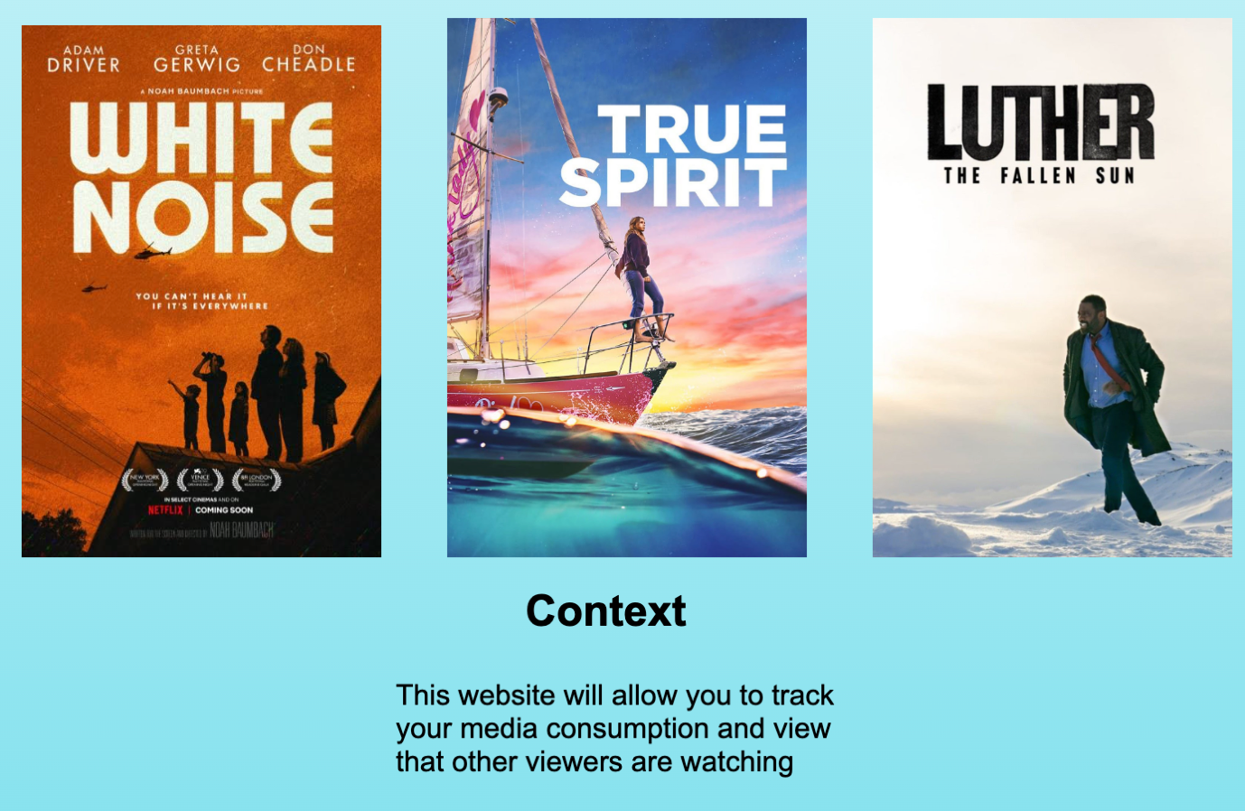

I changed the form by adding a background image for each input and added JavaScript for the user to select a date they submit the form from <https://stackoverflow.com/questions/71953018/html-input-date-field-how-to-set-default-value-to-todays-date>.

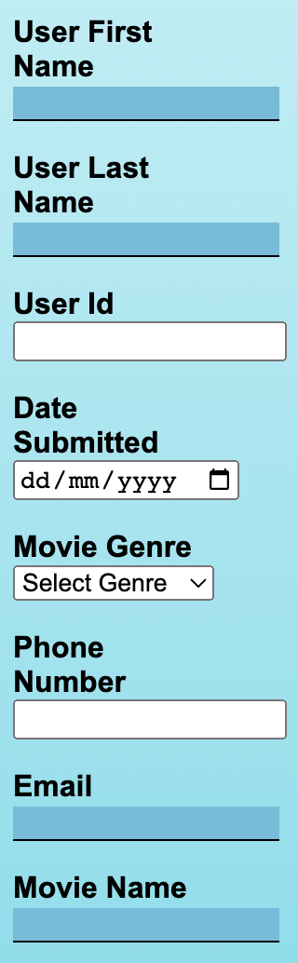

In addition, I added a rating in relation to movie name using pure CSS Star Rating Input from <https://codepen.io/neilpomerleau/pen/wzxzQM>.



I finalised by form and added footer to the bottom of my html document. I found it strange that the image does not pop up when I select an image.

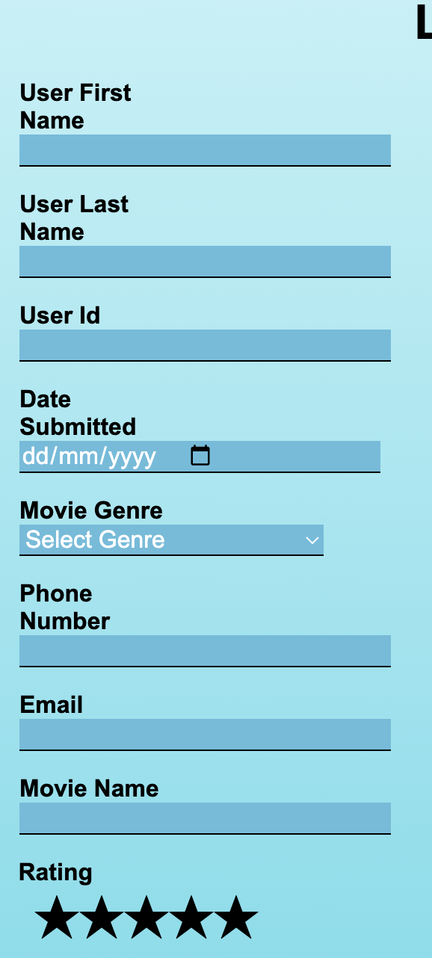

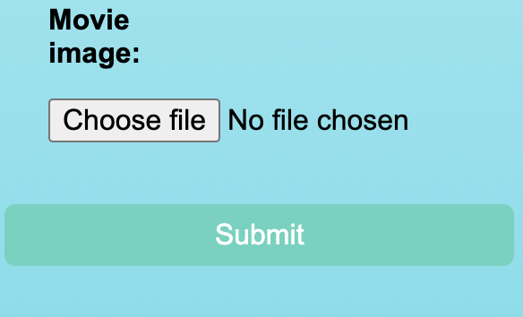

Added a trash bin emoji next to the task list using this link: <https://stackoverflow.com/questions/3705804/css-positioning-elements-next-to-each-other>

Furthermore, I created animations for my title images using fadeIn for 5 seconds. It does not work on my computer and tried to view animation from the developer tools but it’s takes too long.

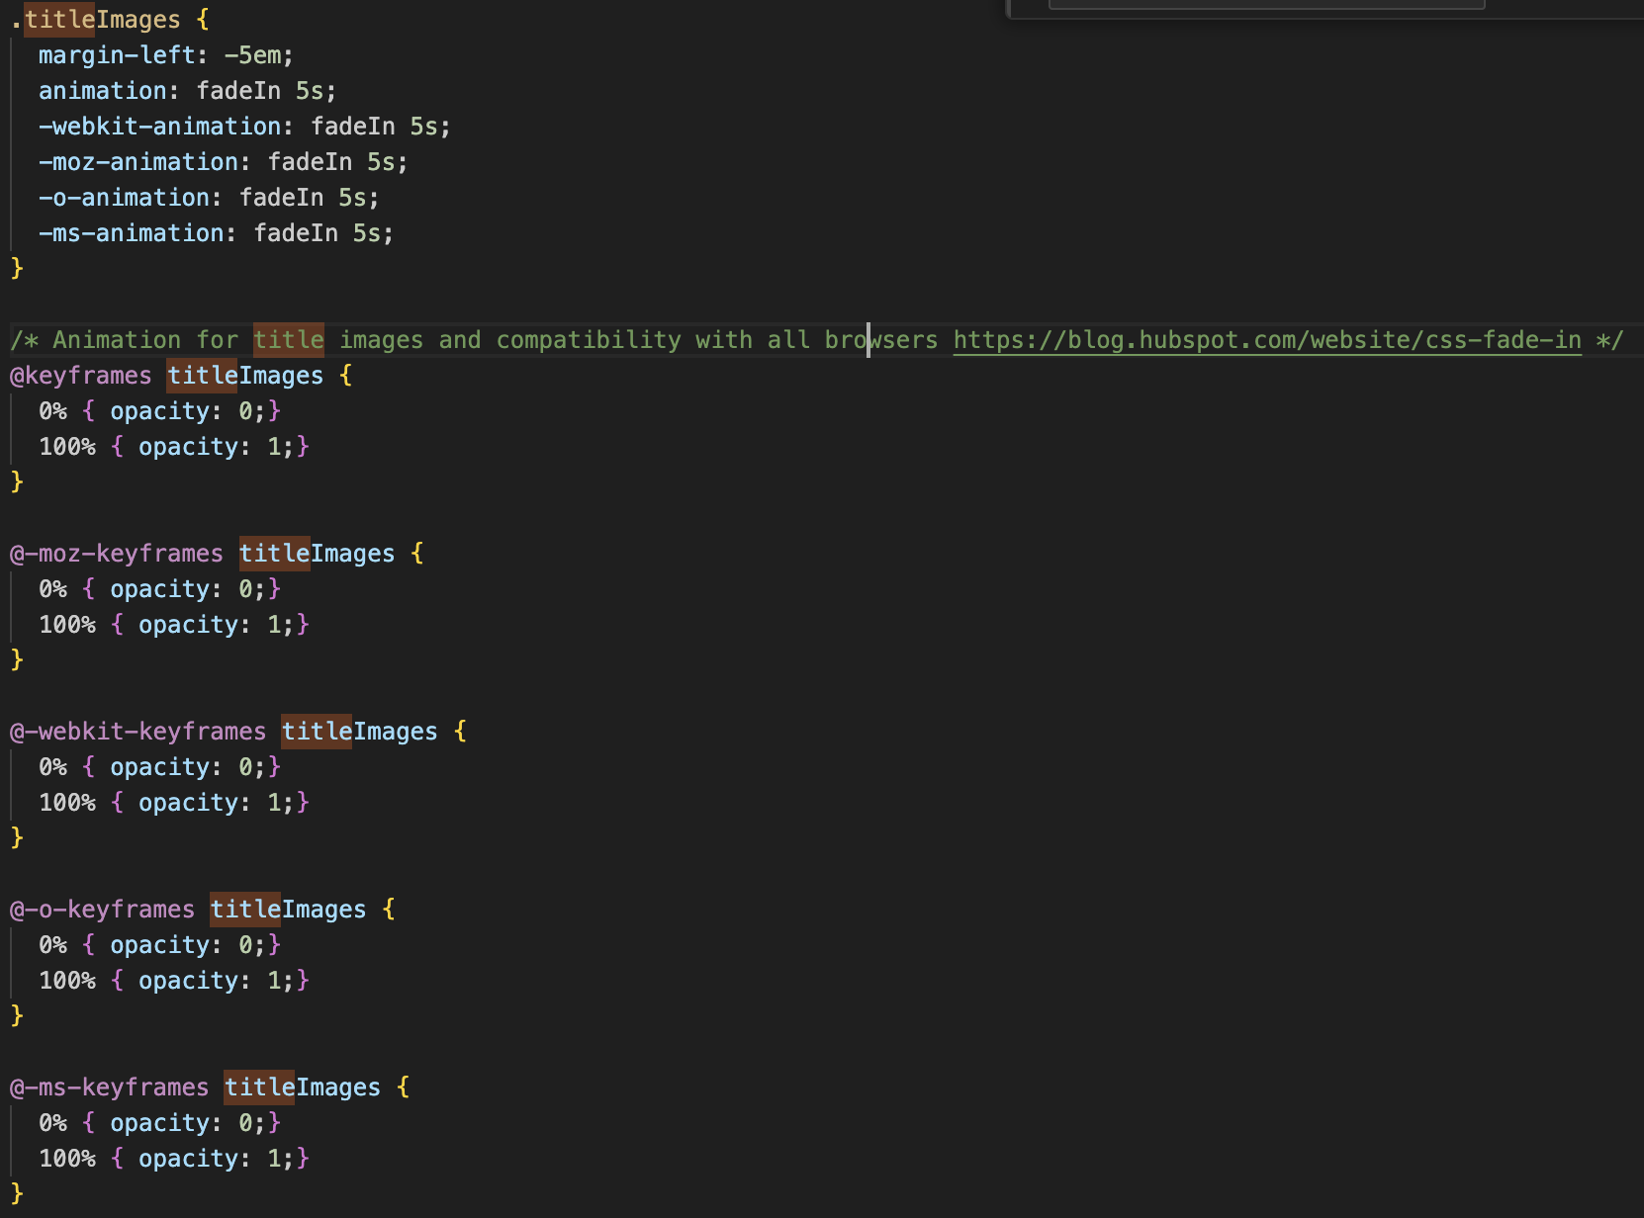

I attempted to edit some JavaScript code to display user’s input but it’s not working. The console displays 2 errors which is frustrating.



24.5.23

I edited all the html elements to fit within the resolution of mobile by adjusting margins and reducing size of top header fonts.